**NOTE: This is an official document by Indexademics. Unless otherwise stated, this document may not be accredited to individuals or groups other than the club IDX, nor should this document be distributed, sold, or modified for personal use in any way.**

**IDX G9 Math H STUDY GUIDE ISSUE**

**By Samuel**

**Isometries**

**Transformation:**

* a transformation of a geometric figure is a change in its position, shape, or size.
* The original figure is the preimage. The resulting figure is an image.(the preimage and image must be similar)
* An isometry is a transformation in which the preimage and image are congruent

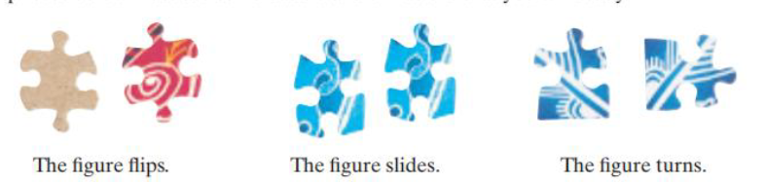

* A transformation maps a figure onto its image and may be described with arrow(--->)notation. Prime (')notation is sometimes used to identify image points
* Notice that you list corresponding points of the preimage and image in the sameorder, as youvdo for corresponding points of congruent or similar figures.

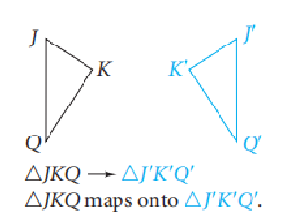

**Translation:**

* a translation(or slide) is an isometry that maps all points of a figure the same distance in the same direction.

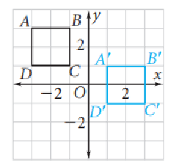

* A **composition** of translation is a combination of two or more transformations. In composition, each transformation is performed on the image of the preceding transformation

**Reflection:**

* A reflection (or fip) is an isometry in which a figure and its image have opposite orientations. Thus, a reflected image in a mirror appears “backwards.”

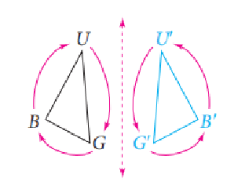

* You can use the following two rules to reflect a figure across a line r.

-If a point A is on line r, then the image of A is A itself (that is,A'=A)

-If a point B is not on line r, then r is the perpendicular bisector of BB'

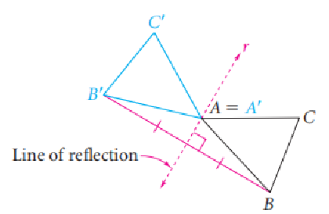

**Rotation:**

* To describe a rotation , you need to know the center of rotation (a point), the angle of rotation (a positive number of degrees)and whether the rotation is clockwise or counterclockwise.Unless stated otherwise.rotations in this book are counterclockwise.
* You can use the following two rules to rotate a figure through x° about a point R:

-The image of R is itself (that is,R'= R)

-For any point V,Rv'= RV and m/VRV'= x.

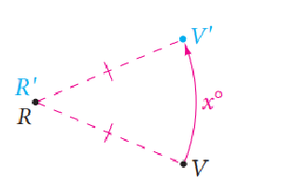

* A regular polygon has a center that is equidistant from its vertices. Segments that connect the center to the vertices divide the polygon into congruent triangles. You can use this fact to find rotation images of regular polygons.

**Composition of Reflections:**

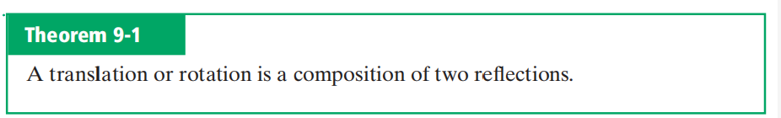

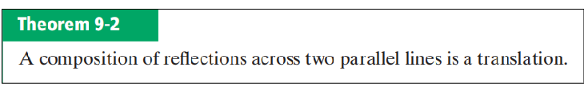

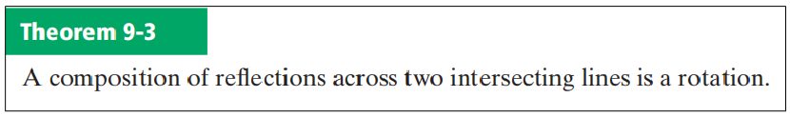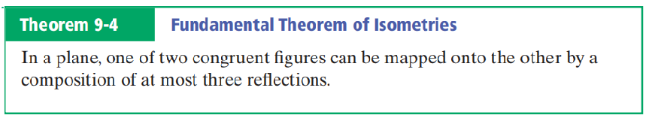

**Glide Reflections:**

* If two figures are congruent and have opposite orientations (but are not simply reflections of each other), then there is a slide and a reflection that will map one onto the other.
* A glide reflection is the composition of a glide (translation) and areflection across a line parallel to the direction of translation.

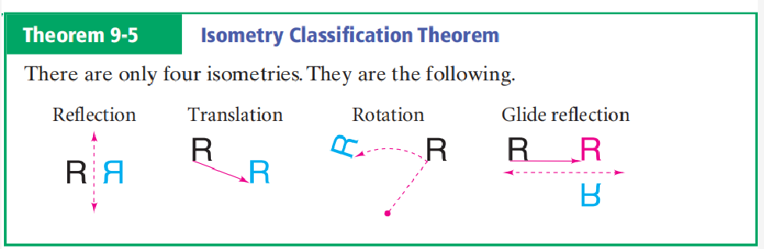

**Symmetry**

**Reflectional Symmetry:**

* A figure has symmetry if there is an isometry that maps the figure onto itself.
* If the isometry is the reflection of a plane figure, the figure has **reflectional symmetry** or **line symmetry.**

**Rotational Symmetry:**

* A figure that has **rotational symmetry** is its own image for some rotation of 180or less.
* A figure that has **point symmetry** has 180° rotational symmetry.
* A square has 90° and 180° rotational symmetry with the center of rotation at the center of the square. Thus, a square also has point symmetry.

**Dilation**

* A dilation is a transformation whose preimage and image are similar. Thus, adilation is a similarity transformation. It is not, in general, an isometry.
* Every dilation has a center and a scale factor n,n >0. The scale factor describes the size change from the original figure to the image.
* To find a dilation with center C and scale factor n,you can use the following two rules.

-The image of C is itself (that is,C'= C).

-'For any point R,R'is on CR and CR'= n·CR

* The dilation is an **enlargement** if the scale factor is greater than 1.The dilation is a **reduction** if the scale factor is between 0 and 1.

